**#Login Form code**

import Java_Project.MainFile;

import javax.swing.JFrame;

import javax.swing.JOptionPane;

/*

* To change this license header, choose License Headers in Project Properties.

* To change this template file, choose Tools | Templates

* and open the template in the editor.

*/

/**

*

* @author Shantanu

*/

public class LoginPage_1 extends javax.swing.JFrame {

/**

* Creates new form LoginPage

*/

public LoginPage_1() {

initComponents();

this.setLocationRelativeTo(null);

}

/**

* This method is called from within the constructor to initialize the form.

* WARNING: Do NOT modify this code. The content of this method is always

* regenerated by the Form Editor.

*/

@SuppressWarnings("unchecked")

// <editor-fold defaultstate="collapsed" desc="Generated Code">//GEN-BEGIN:initComponents

private void initComponents() {

jPanel1 = new javax.swing.JPanel();

jLabel1 = new javax.swing.JLabel();

LabelExit = new javax.swing.JLabel();

jLabelMin = new javax.swing.JLabel();

jPanel2 = new javax.swing.JPanel();

jLabel4 = new javax.swing.JLabel();

jLabel5 = new javax.swing.JLabel();

jTextField1 = new javax.swing.JTextField();

jPasswordField1 = new javax.swing.JPasswordField();

jButton1 = new javax.swing.JButton();

jButton2 = new javax.swing.JButton();

jLabel2 = new javax.swing.JLabel();

setDefaultCloseOperation(javax.swing.WindowConstants.EXIT_ON_CLOSE);

setUndecorated(true);

jPanel1.setBackground(java.awt.Color.orange);

jLabel1.setFont(new java.awt.Font("Times New Roman", 1, 24)); // NOI18N

jLabel1.setText("Login Form");

LabelExit.setFont(new java.awt.Font("Times New Roman", 1, 18)); // NOI18N

LabelExit.setText("X");

LabelExit.setCursor(new java.awt.Cursor(java.awt.Cursor.HAND_CURSOR));

LabelExit.addMouseListener(new java.awt.event.MouseAdapter() {

public void mouseClicked(java.awt.event.MouseEvent evt) {

LabelExitMouseClicked(evt);

}

});

jLabelMin.setFont(new java.awt.Font("Times New Roman", 1, 24)); // NOI18N

jLabelMin.setText("-");

jLabelMin.setCursor(new java.awt.Cursor(java.awt.Cursor.HAND_CURSOR));

jLabelMin.addMouseListener(new java.awt.event.MouseAdapter() {

public void mouseClicked(java.awt.event.MouseEvent evt) {

jLabelMinMouseClicked(evt);

}

});

javax.swing.GroupLayout jPanel1Layout = new javax.swing.GroupLayout(jPanel1);

jPanel1.setLayout(jPanel1Layout);

jPanel1Layout.setHorizontalGroup(

jPanel1Layout.createParallelGroup(javax.swing.GroupLayout.Alignment.LEADING)

.addGroup(jPanel1Layout.createSequentialGroup()

.addGap(37, 37, 37)

.addComponent(jLabel1, javax.swing.GroupLayout.PREFERRED_SIZE, 168, javax.swing.GroupLayout.PREFERRED_SIZE)

.addPreferredGap(javax.swing.LayoutStyle.ComponentPlacement.RELATED, 150, Short.MAX_VALUE)

.addComponent(jLabelMin, javax.swing.GroupLayout.PREFERRED_SIZE, 17, javax.swing.GroupLayout.PREFERRED_SIZE)

.addPreferredGap(javax.swing.LayoutStyle.ComponentPlacement.RELATED)

.addComponent(LabelExit)

.addContainerGap())

);

jPanel1Layout.setVerticalGroup(

jPanel1Layout.createParallelGroup(javax.swing.GroupLayout.Alignment.LEADING)

.addGroup(javax.swing.GroupLayout.Alignment.TRAILING, jPanel1Layout.createSequentialGroup()

.addContainerGap()

.addGroup(jPanel1Layout.createParallelGroup(javax.swing.GroupLayout.Alignment.BASELINE)

.addComponent(jLabel1, javax.swing.GroupLayout.DEFAULT_SIZE, 48, Short.MAX_VALUE)

.addComponent(LabelExit)

.addComponent(jLabelMin))

.addContainerGap())

);

jPanel2.setBackground(new java.awt.Color(153, 153, 153));

jPanel2.setCursor(new java.awt.Cursor(java.awt.Cursor.DEFAULT_CURSOR));

jLabel4.setFont(new java.awt.Font("Times New Roman", 0, 18)); // NOI18N

jLabel4.setText("Password:");

jLabel5.setFont(new java.awt.Font("Times New Roman", 0, 18)); // NOI18N

jLabel5.setText("Username:");

jTextField1.setBackground(new java.awt.Color(204, 204, 204));

jTextField1.setFont(new java.awt.Font("Times New Roman", 0, 14)); // NOI18N

jTextField1.setBorder(javax.swing.BorderFactory.createLineBorder(new java.awt.Color(0, 0, 0)));

jPasswordField1.setBackground(new java.awt.Color(204, 204, 204));

jPasswordField1.setFont(new java.awt.Font("Times New Roman", 0, 14)); // NOI18N

jPasswordField1.setBorder(javax.swing.BorderFactory.createLineBorder(new java.awt.Color(0, 0, 0)));

jButton1.setBackground(new java.awt.Color(51, 153, 255));

jButton1.setFont(new java.awt.Font("Times New Roman", 1, 18)); // NOI18N

jButton1.setForeground(new java.awt.Color(255, 255, 255));

jButton1.setText("Login");

jButton1.setBorder(javax.swing.BorderFactory.createLineBorder(new java.awt.Color(0, 0, 0)));

jButton1.setCursor(new java.awt.Cursor(java.awt.Cursor.HAND_CURSOR));

jButton1.addActionListener(new java.awt.event.ActionListener() {

public void actionPerformed(java.awt.event.ActionEvent evt) {

jButton1ActionPerformed(evt);

}

});

jButton2.setBackground(new java.awt.Color(255, 51, 0));

jButton2.setFont(new java.awt.Font("Times New Roman", 1, 18)); // NOI18N

jButton2.setForeground(new java.awt.Color(255, 255, 255));

jButton2.setText("Cancel");

jButton2.setBorder(javax.swing.BorderFactory.createLineBorder(new java.awt.Color(0, 0, 0)));

jButton2.setCursor(new java.awt.Cursor(java.awt.Cursor.HAND_CURSOR));

jButton2.addActionListener(new java.awt.event.ActionListener() {

public void actionPerformed(java.awt.event.ActionEvent evt) {

jButton2ActionPerformed(evt);

}

});

javax.swing.GroupLayout jPanel2Layout = new javax.swing.GroupLayout(jPanel2);

jPanel2.setLayout(jPanel2Layout);

jPanel2Layout.setHorizontalGroup(

jPanel2Layout.createParallelGroup(javax.swing.GroupLayout.Alignment.LEADING)

.addGroup(jPanel2Layout.createSequentialGroup()

.addGap(77, 77, 77)

.addGroup(jPanel2Layout.createParallelGroup(javax.swing.GroupLayout.Alignment.LEADING)

.addGroup(jPanel2Layout.createSequentialGroup()

.addComponent(jLabel2, javax.swing.GroupLayout.PREFERRED_SIZE, 211, javax.swing.GroupLayout.PREFERRED_SIZE)

.addGap(0, 0, Short.MAX_VALUE))

.addGroup(jPanel2Layout.createSequentialGroup()

.addGroup(jPanel2Layout.createParallelGroup(javax.swing.GroupLayout.Alignment.TRAILING)

.addGroup(jPanel2Layout.createSequentialGroup()

.addComponent(jButton1, javax.swing.GroupLayout.PREFERRED_SIZE, 100, javax.swing.GroupLayout.PREFERRED_SIZE)

.addPreferredGap(javax.swing.LayoutStyle.ComponentPlacement.RELATED, javax.swing.GroupLayout.DEFAULT_SIZE, Short.MAX_VALUE)

.addComponent(jButton2, javax.swing.GroupLayout.PREFERRED_SIZE, 100, javax.swing.GroupLayout.PREFERRED_SIZE))

.addGroup(jPanel2Layout.createSequentialGroup()

.addGroup(jPanel2Layout.createParallelGroup(javax.swing.GroupLayout.Alignment.TRAILING)

.addComponent(jLabel4, javax.swing.GroupLayout.PREFERRED_SIZE, 88, javax.swing.GroupLayout.PREFERRED_SIZE)

.addComponent(jLabel5, javax.swing.GroupLayout.PREFERRED_SIZE, 88, javax.swing.GroupLayout.PREFERRED_SIZE))

.addPreferredGap(javax.swing.LayoutStyle.ComponentPlacement.RELATED, javax.swing.GroupLayout.DEFAULT_SIZE, Short.MAX_VALUE)

.addGroup(jPanel2Layout.createParallelGroup(javax.swing.GroupLayout.Alignment.LEADING, false)

.addComponent(jTextField1)

.addComponent(jPasswordField1, javax.swing.GroupLayout.DEFAULT_SIZE, 172, Short.MAX_VALUE))))

.addGap(74, 74, 74))))

);

jPanel2Layout.setVerticalGroup(

jPanel2Layout.createParallelGroup(javax.swing.GroupLayout.Alignment.LEADING)

.addGroup(jPanel2Layout.createSequentialGroup()

.addGap(62, 62, 62)

.addGroup(jPanel2Layout.createParallelGroup(javax.swing.GroupLayout.Alignment.BASELINE)

.addComponent(jTextField1, javax.swing.GroupLayout.PREFERRED_SIZE, javax.swing.GroupLayout.DEFAULT_SIZE, javax.swing.GroupLayout.PREFERRED_SIZE)

.addComponent(jLabel5, javax.swing.GroupLayout.PREFERRED_SIZE, 31, javax.swing.GroupLayout.PREFERRED_SIZE))

.addPreferredGap(javax.swing.LayoutStyle.ComponentPlacement.UNRELATED)

.addGroup(jPanel2Layout.createParallelGroup(javax.swing.GroupLayout.Alignment.BASELINE)

.addComponent(jLabel4, javax.swing.GroupLayout.PREFERRED_SIZE, 31, javax.swing.GroupLayout.PREFERRED_SIZE)

.addComponent(jPasswordField1, javax.swing.GroupLayout.PREFERRED_SIZE, javax.swing.GroupLayout.DEFAULT_SIZE, javax.swing.GroupLayout.PREFERRED_SIZE))

.addGap(18, 18, 18)

.addGroup(jPanel2Layout.createParallelGroup(javax.swing.GroupLayout.Alignment.BASELINE)

.addComponent(jButton2, javax.swing.GroupLayout.PREFERRED_SIZE, 40, javax.swing.GroupLayout.PREFERRED_SIZE)

.addComponent(jButton1, javax.swing.GroupLayout.PREFERRED_SIZE, 40, javax.swing.GroupLayout.PREFERRED_SIZE))

.addPreferredGap(javax.swing.LayoutStyle.ComponentPlacement.RELATED, 53, Short.MAX_VALUE)

.addComponent(jLabel2)

.addGap(7, 7, 7))

);

javax.swing.GroupLayout layout = new javax.swing.GroupLayout(getContentPane());

getContentPane().setLayout(layout);

layout.setHorizontalGroup(

layout.createParallelGroup(javax.swing.GroupLayout.Alignment.LEADING)

.addComponent(jPanel1, javax.swing.GroupLayout.PREFERRED_SIZE, javax.swing.GroupLayout.DEFAULT_SIZE, javax.swing.GroupLayout.PREFERRED_SIZE)

.addComponent(jPanel2, javax.swing.GroupLayout.PREFERRED_SIZE, 400, javax.swing.GroupLayout.PREFERRED_SIZE)

);

layout.setVerticalGroup(

layout.createParallelGroup(javax.swing.GroupLayout.Alignment.LEADING)

.addGroup(layout.createSequentialGroup()

.addComponent(jPanel1, javax.swing.GroupLayout.PREFERRED_SIZE, javax.swing.GroupLayout.DEFAULT_SIZE, javax.swing.GroupLayout.PREFERRED_SIZE)

.addPreferredGap(javax.swing.LayoutStyle.ComponentPlacement.RELATED, javax.swing.GroupLayout.DEFAULT_SIZE, Short.MAX_VALUE)

.addComponent(jPanel2, javax.swing.GroupLayout.PREFERRED_SIZE, javax.swing.GroupLayout.DEFAULT_SIZE, javax.swing.GroupLayout.PREFERRED_SIZE)

.addContainerGap())

);

pack();

}// </editor-fold>//GEN-END:initComponents

private void LabelExitMouseClicked(java.awt.event.MouseEvent evt) {//GEN-FIRST:event_LabelExitMouseClicked

System.exit(0); // TODO add your handling code here:

}//GEN-LAST:event_LabelExitMouseClicked

private void jLabelMinMouseClicked(java.awt.event.MouseEvent evt) {//GEN-FIRST:event_jLabelMinMouseClicked

this.setState(JFrame.ICONIFIED); // TODO add your handling code here:

}//GEN-LAST:event_jLabelMinMouseClicked

private void jButton1ActionPerformed(java.awt.event.ActionEvent evt) {//GEN-FIRST:event_jButton1ActionPerformed

String s1=jTextField1.getText();

String s2=jPasswordField1.getText();

if(s1.equals("admin")&& s2.equals("admin"))

{

dispose();

new MainFile();

System.out.println("Hello");

}

else

{

JOptionPane.showMessageDialog(null, "Incorrect username or password\nPlease Try again!!!");

}

}//GEN-LAST:event_jButton1ActionPerformed

private void jButton2ActionPerformed(java.awt.event.ActionEvent evt) {//GEN-FIRST:event_2Button1ActionPerformed

jTextField1.setText("");

jPasswordField1.setText("");

}//GEN-LAST:event_jButton2ActionPerformed

/**

* @param args the command line arguments

*/

public static void main(String args[]) {

/* Set the Nimbus look and feel */

//<editor-fold defaultstate="collapsed" desc=" Look and feel setting code (optional) ">

/* If Nimbus (introduced in Java SE 6) is not available, stay with the default look and feel.

* For details see http://download.oracle.com/javase/tutorial/uiswing/lookandfeel/plaf.html

*/

try {

for (javax.swing.UIManager.LookAndFeelInfo info : javax.swing.UIManager.getInstalledLookAndFeels()) {

if ("Nimbus".equals(info.getName())) {

javax.swing.UIManager.setLookAndFeel(info.getClassName());

break;

}

}

} catch (ClassNotFoundException ex) {

java.util.logging.Logger.getLogger(LoginPage.class.getName()).log(java.util.logging.Level.SEVERE, null, ex);

} catch (InstantiationException ex) {

java.util.logging.Logger.getLogger(LoginPage.class.getName()).log(java.util.logging.Level.SEVERE, null, ex);

} catch (IllegalAccessException ex) {

java.util.logging.Logger.getLogger(LoginPage.class.getName()).log(java.util.logging.Level.SEVERE, null, ex);

} catch (javax.swing.UnsupportedLookAndFeelException ex) {

java.util.logging.Logger.getLogger(LoginPage.class.getName()).log(java.util.logging.Level.SEVERE, null, ex);

}

//</editor-fold>

/* Create and display the form */

java.awt.EventQueue.invokeLater(new Runnable() {

public void run() {

new LoginPage_1().setVisible(true);

}

});

}

// Variables declaration - do not modify//GEN-BEGIN:variables

private javax.swing.JLabel LabelExit;

private javax.swing.JButton jButton1;

private javax.swing.JButton jButton2;

private javax.swing.JLabel jLabel1;

private javax.swing.JLabel jLabel2;

private javax.swing.JLabel jLabel4;

private javax.swing.JLabel jLabel5;

private javax.swing.JLabel jLabelMin;

private javax.swing.JPanel jPanel1;

private javax.swing.JPanel jPanel2;

private javax.swing.JPasswordField jPasswordField1;

private javax.swing.JTextField jTextField1;

// End of variables declaration//GEN-END:variables

}

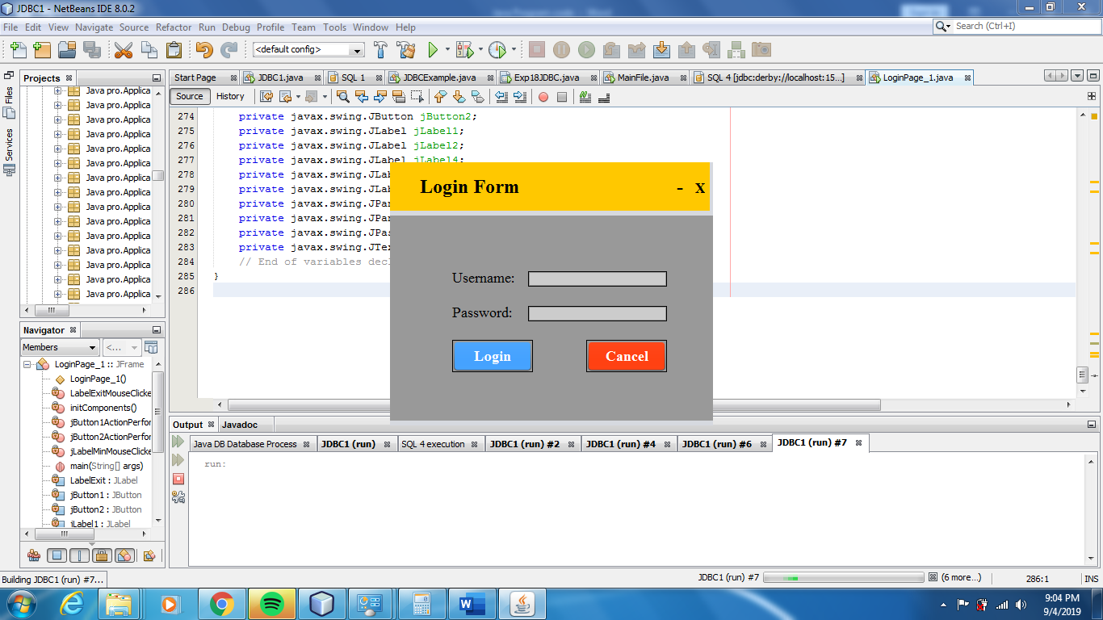

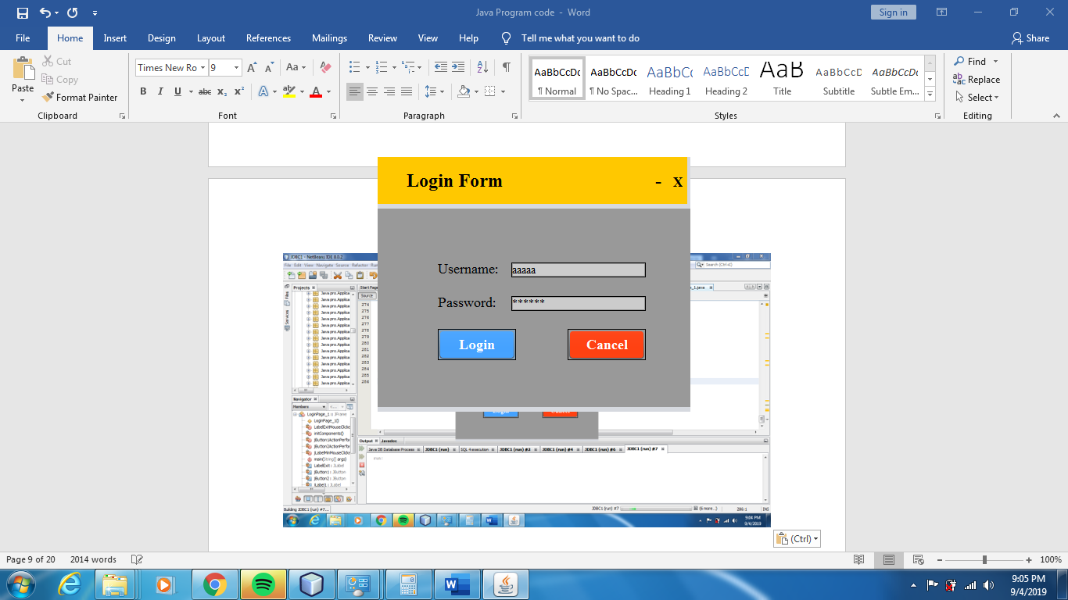

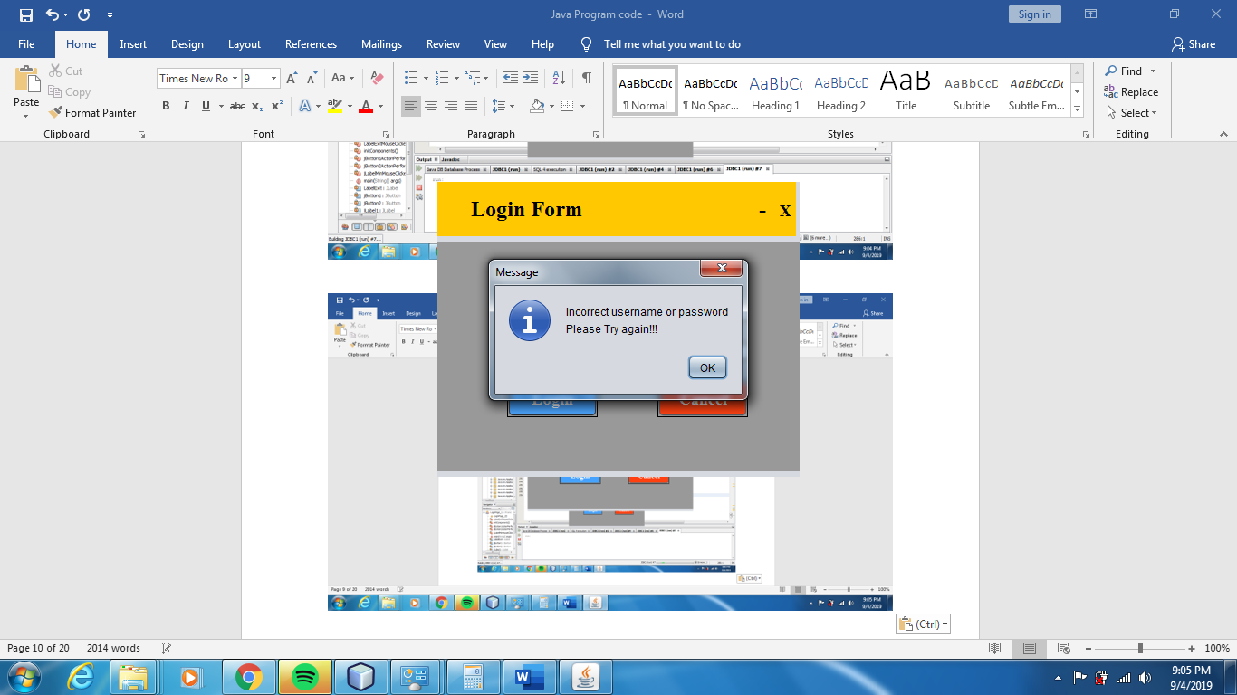

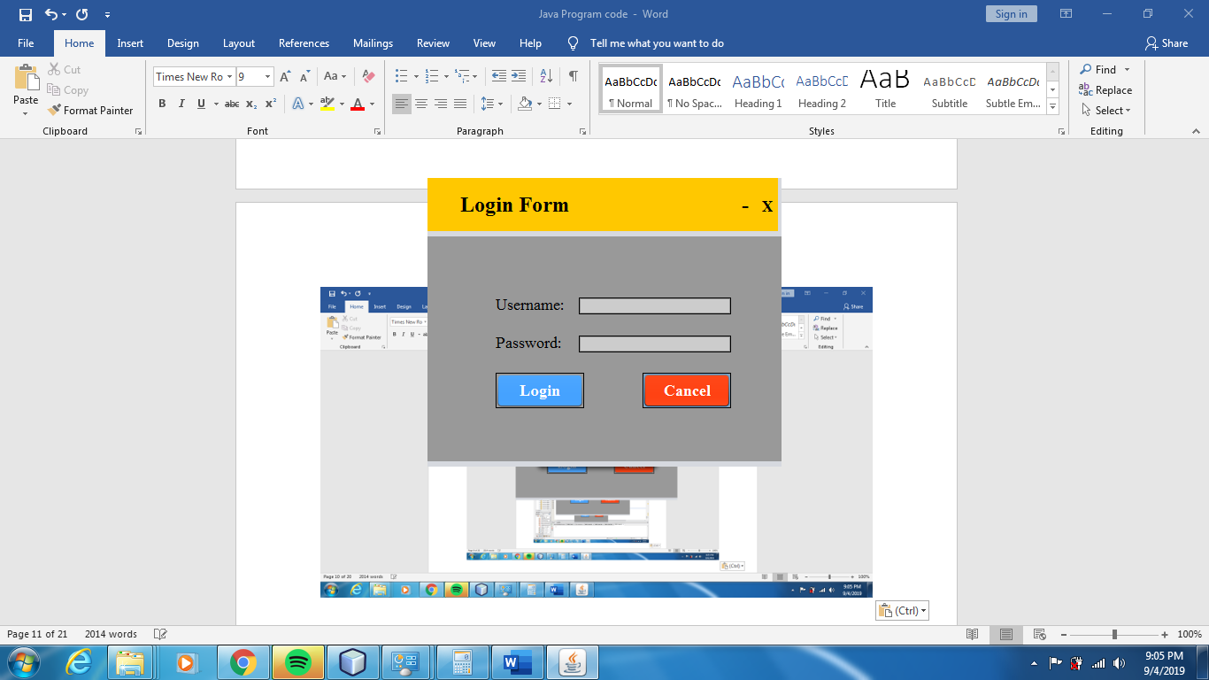

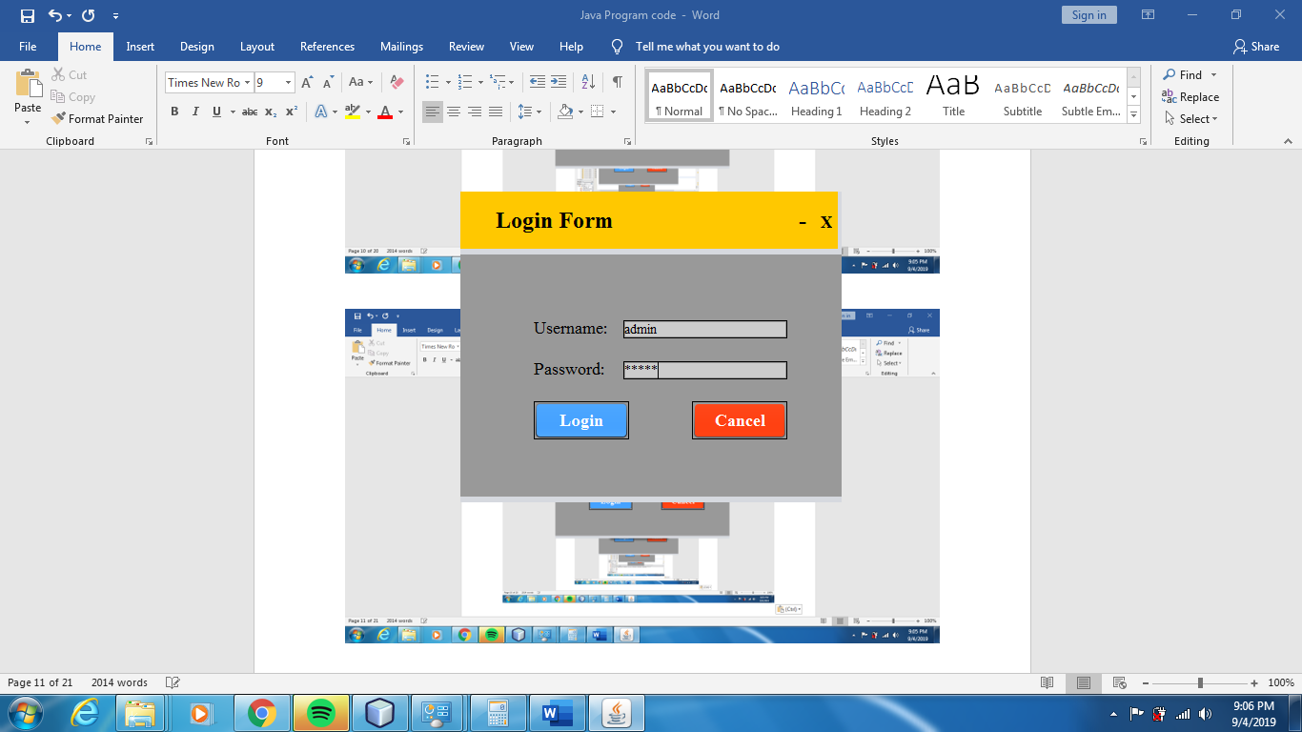

**#Application Launcher program code**

package Java_Project;

import java.util.concurrent.TimeUnit;

import java.awt.*;

import java.awt.event.*;

import java.io.IOException.*;

import java.util.Date;

import javax.swing.*;

import java.io.*;

import java.awt.Desktop;

import java.io.File;

import java.net.URI;

import java.sql.Connection;

import java.sql.DriverManager;

import java.sql.ResultSet;

import java.sql.SQLException;

import java.sql.Statement;

import java.text.DateFormat;

import java.text.SimpleDateFormat;

import java.util.Calendar;

public class MainFile extends JFrame

{

public MainFile()

{

int x,y,i,c;

final String paath="jdbc:derby://localhost:1527/ApplicationLaucher";

final String username_password="admin1";

String admin="'admin'";

Connection myconobj = null;

Statement mystatobj = null;

String deletequery="delete from ADMIN1.APPLICATIONLAUNCHER where username='admin'";

ResultSet myresobj = null;

try {

myconobj = DriverManager.getConnection(paath, username_password, username_password);

mystatobj = (Statement) myconobj.createStatement();

mystatobj.executeUpdate(deletequery);

}

catch (SQLException sqle) {

sqle.printStackTrace();

}

//final ButtonExample1 o1=new ButtonExample1();

final File fileword = new File("C:/Users/Shantanu/Documents/NetBeansProjects/JDBC1/src/Java pro/Documents/Word Documents/Untitled.docx");

final File fileppt = new File("C:/Users/Shantanu/Documents/NetBeansProjects/JDBC1/src/Java pro/Documents/Power Point Presentations/Untitled.pptx");

final File fileaccess = new File("C:/Users/Shantanu/Documents/NetBeansProjects/JDBC1/src/Java pro/Documents/Microsoft Access/Untitled.accdb");

x=380;

y=150;

i=130;

c=10;

JFrame f=new JFrame("Application Launcher");

f.setSize(2000,1000) ;

f.getContentPane().setBackground(Color.WHITE);

JButton notepad,chrome,turboC,sublimeText,word,ppt,access,youtube,gmail,arduino,calculator;

ImageIcon notepadImg,chromeImg,turboCImg,sublimeTextImg,wordImg,pptImg,accessImg,youtubeImg,gmailImg,arduinoImg,calculatorImg;

JLabel clickLabel,applicationLauncher,notepadLabel,chromeLabel,turboCLabel,sublimeTextLabel,arduinoLabel1,wordLabel1,wordLabel2,calculatorLabel,gmailLabel1,youtubeLabel1,pptLabel1,pptLabel2,accessLabel1,accessLabel2;

Font font=new Font("Catholic", Font.BOLD, 20);

System.out.println("Hello");

applicationLauncher=new JLabel("APPLICATION LAUNCHER");

applicationLauncher.setFont(new Font("Catholic", Font.BOLD, 50));

applicationLauncher.setBounds(300,20,1000,100);

applicationLauncher.setForeground(Color.RED);

chromeLabel=new JLabel("Chrome");

chromeLabel.setFont(font);

chromeImg = new ImageIcon("C:\\Users\\Shantanu\\Documents\\NetBeansProjects\\JDBC1\\src\\Java pro\\Java_Project\\resources\\GoogleChrome1.jpg"); //set image for chrome

chrome = new JButton(chromeImg);

chrome.setToolTipText("Click to Chrome browser");

chrome.setBackground(Color.WHITE);

chrome.setBounds(c+x,30+y,100,100);

chromeLabel.setBounds(c+10+x,100+y,100,100);

notepadLabel=new JLabel("Notepad");

notepadLabel.setFont(font);

notepadImg = new ImageIcon("C:\\Users\\Shantanu\\Documents\\NetBeansProjects\\JDBC1\\src\\Java pro\\Java_Project\\resources\\Notepad1_1.png");

notepad=new JButton(notepadImg);

notepad.setToolTipText("Click to open Notepad");

notepad.setBackground(Color.WHITE);

c=c+i;

notepad.setBounds(c+x,30+y,100,100);

notepadLabel.setBounds(c+10+x,100+y,100,100);

turboCLabel=new JLabel("Turbo C++");

turboCLabel.setFont(font);

turboCImg = new ImageIcon("C:\\Users\\Shantanu\\Documents\\NetBeansProjects\\JDBC1\\src\\Java pro\\Java_Project\\resources\\TurboC.png");

turboC=new JButton(turboCImg);

turboC.setToolTipText("Click to open TurboC++");

turboC.setBackground(Color.WHITE);

c=c+i;

turboC.setBounds(c+x,30+y,100,100);

turboCLabel.setBounds(c+10+x,100+y,100,100);

sublimeTextLabel=new JLabel("Sublime Text");

sublimeTextLabel.setFont(font);

sublimeTextImg = new ImageIcon("C:\\Users\\Shantanu\\Documents\\NetBeansProjects\\JDBC1\\src\\Java pro\\Java_Project\\resources\\SublimeText1_1.png");

sublimeText=new JButton(sublimeTextImg);

sublimeText.setToolTipText("Click to open Sublime text");

sublimeText.setBackground(Color.WHITE);

c=c+i;

sublimeText.setBounds(c+x,30+y,100,100);

sublimeTextLabel.setBounds(c+10+x-20,100+y,150,100);

c=10;

wordLabel1=new JLabel("Microsoft");

wordLabel2=new JLabel("Word");

wordLabel1.setFont(font);

wordLabel2.setFont(font);

wordImg = new ImageIcon("C:\\Users\\Shantanu\\Documents\\NetBeansProjects\\JDBC1\\src\\Java pro\\Java_Project\\resources\\Word1.png");

word=new JButton(wordImg);

word.setToolTipText("Click to open Microsoft Word");

word.setBackground(Color.WHITE);

word.setBounds(c+x,200+y,100,100);

wordLabel1.setBounds(c+x,270+y,150,100);

wordLabel2.setBounds(c+x,270+y+20,150,100);

pptLabel1=new JLabel("Microsoft");

pptLabel2=new JLabel("Powerpoint");

pptLabel1.setFont(font);

pptLabel2.setFont(font);

pptImg = new ImageIcon("C:\\Users\\Shantanu\\Documents\\NetBeansProjects\\JDBC1\\src\\Java pro\\Java_Project\\resources\\ppt1_1.png");

ppt=new JButton(pptImg);

ppt.setToolTipText("Click to open Microsoft Powerpoint");

ppt.setBackground(Color.WHITE);

c=c+i;

ppt.setBounds(c+x,200+y,100,100);

pptLabel1.setBounds(c+x,270+y,150,100);

pptLabel2.setBounds(c+x,270+y+20,150,100);

accessLabel1=new JLabel("Microsoft");

accessLabel2=new JLabel("Access");

accessLabel1.setFont(font);

accessLabel2.setFont(font);

accessImg = new ImageIcon("C:\\Users\\Shantanu\\Documents\\NetBeansProjects\\JDBC1\\src\\Java pro\\Java_Project\\resources\\access1_1.jpg");

access=new JButton(accessImg);

access.setToolTipText("Click to open Microsoft Access");

access.setBackground(Color.WHITE);

c=c+i;

access.setBounds(c+x,200+y,100,100);

accessLabel1.setBounds(c+x,270+y,150,100);

accessLabel2.setBounds(c+x,270+y+20,150,100);

youtubeLabel1=new JLabel("Youtube");

youtubeLabel1.setFont(font);

youtubeImg = new ImageIcon("C:\\Users\\Shantanu\\Documents\\NetBeansProjects\\JDBC1\\src\\Java pro\\Java_Project\\resources\\youtube1.png");

youtube=new JButton(youtubeImg);

youtube.setToolTipText("Click to open Youtube");

youtube.setBackground(Color.WHITE);

c=c+i;

youtube.setBounds(c+x,200+y,100,100);

youtubeLabel1.setBounds(c+x,270+y,150,100);

c=10;

gmailLabel1=new JLabel("Gmail");

gmailLabel1.setFont(font);

gmailImg = new ImageIcon("C:\\Users\\Shantanu\\Documents\\NetBeansProjects\\JDBC1\\src\\Java pro\\Java_Project\\resources\\gmail1.png");

gmail=new JButton(gmailImg);

gmail.setToolTipText("Click to open Gmail");

gmail.setBackground(Color.WHITE);

gmail.setBounds(c+x,370+y,100,100);

gmailLabel1.setBounds(c+x+10,440+y,150,100);

calculatorLabel=new JLabel("calculator");

calculatorLabel.setFont(font);

calculatorImg = new ImageIcon("C:\\Users\\Shantanu\\Documents\\NetBeansProjects\\JDBC1\\src\\Java pro\\Java_Project\\resources\\calculator1_1.png");

calculator=new JButton(calculatorImg);

calculator.setToolTipText("Click to open calculator");

calculator.setBackground(Color.WHITE);

c=c+i;

calculator.setBounds(c+x,370+y,100,100);

calculatorLabel.setBounds(c+10+x,440+y,100,100);

calculator.addActionListener(new ActionListener()

{

public void actionPerformed(ActionEvent e)

{

Runtime rs = Runtime.getRuntime();

System.out.println("Calculator was opened");

try

{

rs.exec("calc");

data();

}

catch (Exception eb)

{

System.out.println(eb);

}

Connection myconobj = null;

Statement mystatobj = null;

ResultSet myresobj = null;

Calendar cal = Calendar.getInstance();

SimpleDateFormat sdf = new SimpleDateFormat("HH:mm:ss");

System.out.println( sdf.format(cal.getTime()) );

String query = "insert into APPLICATIONLAUNCHER values('admin','calculator','"+sdf.format(cal.getTime())+"')";

try {

myconobj = DriverManager.getConnection(paath, username_password, username_password);

mystatobj = (Statement) myconobj.createStatement();

mystatobj.executeUpdate(query);

System.out.println("Data Inserted in table");

}

catch (SQLException sqle) {

sqle.printStackTrace();

}

}

});

notepad.addActionListener(new ActionListener()

{

public void actionPerformed(ActionEvent e)

{

Runtime rs = Runtime.getRuntime();

System.out.println("Notepad was opened");

try

{

rs.exec("notepad");

data();

}

catch (Exception eb)

{

System.out.println(eb);

}

Connection myconobj = null;

Statement mystatobj = null;

ResultSet myresobj = null;

Calendar cal = Calendar.getInstance();

SimpleDateFormat sdf = new SimpleDateFormat("HH:mm:ss");

System.out.println( sdf.format(cal.getTime()) );

String query = "insert into APPLICATIONLAUNCHER values('admin','Notepad','"+sdf.format(cal.getTime())+"')";

try {

myconobj = DriverManager.getConnection(paath, username_password, username_password);

mystatobj = (Statement) myconobj.createStatement();

mystatobj.executeUpdate(query);

System.out.println("Data Inserted in table");

}

catch (SQLException sqle) {

sqle.printStackTrace();

}

}

});

chrome.addActionListener(new ActionListener()

{

public void actionPerformed(ActionEvent e)

{

Runtime rs = Runtime.getRuntime();

System.out.println("Chrome was opened");

try

{

rs.exec("\"C:/Users/Shantanu/Documents/NetBeansProjects/JDBC1/src/Java pro/Application setups/Google/Chrome/Application/chrome.exe\"");

data();

}

catch (Exception eb)

{

System.out.println(eb);

}

Connection myconobj = null;

Statement mystatobj = null;

ResultSet myresobj = null;

Calendar cal = Calendar.getInstance();

SimpleDateFormat sdf = new SimpleDateFormat("HH:mm:ss");

System.out.println( sdf.format(cal.getTime()) );

String query = "insert into APPLICATIONLAUNCHER values('admin','Chrome','"+sdf.format(cal.getTime())+"')";

try {

myconobj = DriverManager.getConnection(paath, username_password, username_password);

mystatobj = (Statement) myconobj.createStatement();

mystatobj.executeUpdate(query);

System.out.println("Data Inserted in table");

}

catch (SQLException sqle) {

sqle.printStackTrace();

}

}

});

turboC.addActionListener(new ActionListener()

{

public void actionPerformed(ActionEvent e)

{

Runtime rs = Runtime.getRuntime();

System.out.println("TurboC++ was opened");

try

{

rs.exec("\"C:/Users/Shantanu/Documents/NetBeansProjects/JDBC1/src/Java pro/Application setups/Turbo C++/Turbo C++.exe\"");

data();

}

catch (Exception eb)

{

System.out.println(eb);

}

Connection myconobj = null;

Statement mystatobj = null;

ResultSet myresobj = null;

Calendar cal = Calendar.getInstance();

SimpleDateFormat sdf = new SimpleDateFormat("HH:mm:ss");

System.out.println( sdf.format(cal.getTime()) );

String query = "insert into APPLICATIONLAUNCHER values('admin','TurboC++','"+sdf.format(cal.getTime())+"')";

try {

myconobj = DriverManager.getConnection(paath, username_password, username_password);

mystatobj = (Statement) myconobj.createStatement();

mystatobj.executeUpdate(query);

System.out.println("Data Inserted in table");

}

catch (SQLException sqle) {

sqle.printStackTrace();

}

}

});

sublimeText.addActionListener(new ActionListener()

{

public void actionPerformed(ActionEvent e)

{

Runtime rs = Runtime.getRuntime();

System.out.println("Sublime text was opened");

try

{

rs.exec("\"C:/Users/Shantanu/Documents/NetBeansProjects/JDBC1/src/Java pro/Application setups/Sublime text portable/sublime_text.exe\"");

data();

}

catch (Exception eb)

{

System.out.println(eb);

}

Connection myconobj = null;

Statement mystatobj = null;

ResultSet myresobj = null;

Calendar cal = Calendar.getInstance();

SimpleDateFormat sdf = new SimpleDateFormat("HH:mm:ss");

System.out.println( sdf.format(cal.getTime()) );

String query = "insert into APPLICATIONLAUNCHER values('admin','Sublime_text','"+sdf.format(cal.getTime())+"')";

try {

myconobj = DriverManager.getConnection(paath, username_password, username_password);

mystatobj = (Statement) myconobj.createStatement();

mystatobj.executeUpdate(query);

System.out.println("Data Inserted in table");

}

catch (SQLException sqle) {

sqle.printStackTrace();

}

}

});

word.addActionListener(new ActionListener()

{

public void actionPerformed(ActionEvent e)

{

System.out.println("Microsoft word was opened");

try {

//Open the file using Desktop class

Desktop.getDesktop().open(fileword);

data();

}catch (IOException exception){

exception.printStackTrace();

}

Connection myconobj = null;

Statement mystatobj = null;

ResultSet myresobj = null;

Calendar cal = Calendar.getInstance();

SimpleDateFormat sdf = new SimpleDateFormat("HH:mm:ss");

System.out.println( sdf.format(cal.getTime()) );

String query = "insert into APPLICATIONLAUNCHER values('admin','Microsoft_Word','"+sdf.format(cal.getTime())+"')";

try {

myconobj = DriverManager.getConnection(paath, username_password, username_password);

mystatobj = (Statement) myconobj.createStatement();

mystatobj.executeUpdate(query);

System.out.println("Data Inserted in table");

}

catch (SQLException sqle) {

sqle.printStackTrace();

}

}

});

ppt.addActionListener(new ActionListener()

{

public void actionPerformed(ActionEvent e)

{

System.out.println("Microsoft Powerpoint was opened");

try {

//Open the file using Desktop class

Desktop.getDesktop().open(fileppt);

data();

}catch (IOException exception){

exception.printStackTrace();

}

Connection myconobj = null;

Statement mystatobj = null;

ResultSet myresobj = null;

Calendar cal = Calendar.getInstance();

SimpleDateFormat sdf = new SimpleDateFormat("HH:mm:ss");

System.out.println( sdf.format(cal.getTime()) );

String query = "insert into APPLICATIONLAUNCHER values('admin','Powerpoint_presentation','"+sdf.format(cal.getTime())+"')";

try {

myconobj = DriverManager.getConnection(paath, username_password, username_password);

mystatobj = (Statement) myconobj.createStatement();

mystatobj.executeUpdate(query);

System.out.println("Data Inserted in table");

}

catch (SQLException sqle) {

sqle.printStackTrace();

}

}

});

access.addActionListener(new ActionListener()

{

public void actionPerformed(ActionEvent e)

{

System.out.println("Microsoft Access was opened");

try {

//Open the file using Desktop class

Desktop.getDesktop().open(fileaccess);

data();

}catch (IOException exception){

exception.printStackTrace();

}

Connection myconobj = null;

Statement mystatobj = null;

ResultSet myresobj = null;

Calendar cal = Calendar.getInstance();

SimpleDateFormat sdf = new SimpleDateFormat("HH:mm:ss");

System.out.println( sdf.format(cal.getTime()) );

String query = "insert into APPLICATIONLAUNCHER values('admin','Microsoft_Access','"+sdf.format(cal.getTime())+"')";

try {

myconobj = DriverManager.getConnection(paath, username_password, username_password);

mystatobj = (Statement) myconobj.createStatement();

mystatobj.executeUpdate(query);

System.out.println("Data Inserted in table");

}

catch (SQLException sqle) {

sqle.printStackTrace();

}

}

});

youtube.addActionListener(new ActionListener()

{

public void actionPerformed(ActionEvent e)

{

System.out.println("Youtube was opened");

try {

URI uri= new URI("http://www.youtube.com");

data();

java.awt.Desktop.getDesktop().browse(uri);

} catch (Exception ex) {

ex.printStackTrace();

}

Connection myconobj = null;

Statement mystatobj = null;

ResultSet myresobj = null;

Calendar cal = Calendar.getInstance();

SimpleDateFormat sdf = new SimpleDateFormat("HH:mm:ss");

System.out.println( sdf.format(cal.getTime()) );

String query = "insert into APPLICATIONLAUNCHER values('admin','Youtube','"+sdf.format(cal.getTime())+"')";

try {

myconobj = DriverManager.getConnection(paath, username_password, username_password);

mystatobj = (Statement) myconobj.createStatement();

mystatobj.executeUpdate(query);

System.out.println("Data Inserted in table");

}

catch (SQLException sqle) {

sqle.printStackTrace();

}

}

});

gmail.addActionListener(new ActionListener()

{

public void actionPerformed(ActionEvent e)

{

System.out.println("Gmail was opened");

try {

URI uri= new URI("http://www.gmail.com");

data();

java.awt.Desktop.getDesktop().browse(uri);

} catch (Exception ex) {

ex.printStackTrace();

}

Connection myconobj = null;

Statement mystatobj = null;

ResultSet myresobj = null;

Calendar cal = Calendar.getInstance();

SimpleDateFormat sdf = new SimpleDateFormat("HH:mm:ss");

System.out.println( sdf.format(cal.getTime()) );

String query = "insert into APPLICATIONLAUNCHER values('admin','Gmail','"+sdf.format(cal.getTime())+"')";

try {

myconobj = DriverManager.getConnection(paath, username_password, username_password);

mystatobj = (Statement) myconobj.createStatement();

mystatobj.executeUpdate(query);

System.out.println("Data Inserted in table");

}

catch (SQLException sqle) {

sqle.printStackTrace();

}

}

});

f.setLayout(null);

f.add(notepad);

f.add(chrome);

f.add(turboC);

f.add(sublimeText);

f.add(chromeLabel);

f.add(notepadLabel);

f.add(turboCLabel);

f.add(sublimeTextLabel);

f.add(word);

f.add(wordLabel1);

f.add(gmail);

f.add(gmailLabel1);

f.add(wordLabel2);

f.add(ppt);

f.add(pptLabel1);

f.add(pptLabel2);

f.add(access);

f.add(accessLabel1);

f.add(accessLabel2);

f.add(youtubeLabel1);

f.add(youtube);

f.add(calculator);

f.add(calculatorLabel);

f.add(applicationLauncher);

f.setVisible(true);

data();

}

public static void main(String[] args) {

MainFile mainfile=new MainFile();

}

public int data()

{

try{

long startTime = System.nanoTime();

// ... the code being measured starts ...

// sleep for 5 seconds

TimeUnit.SECONDS.sleep(5);

// ... the code being measured ends ...

long endTime = System.nanoTime();

long timeElapsed = endTime - startTime;

System.out.println("Execution time in nanoseconds: " + timeElapsed);

System.out.println("Execution time in milliseconds: " + timeElapsed / 1000000);

}

catch(Exception except)

{

}

return 0;

}

}

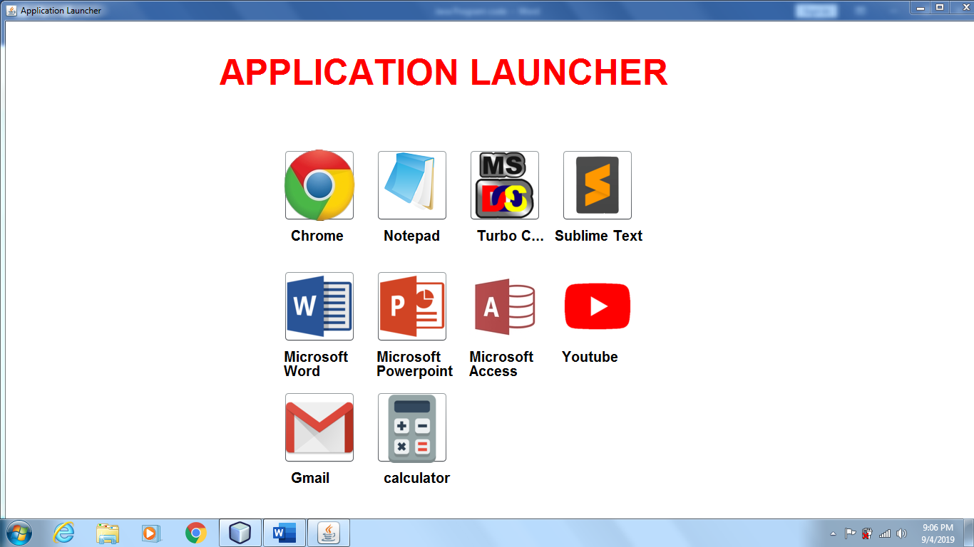

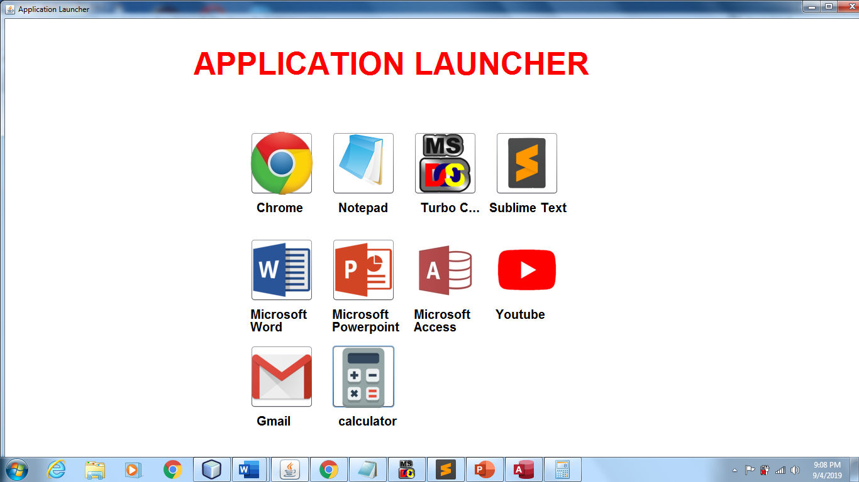

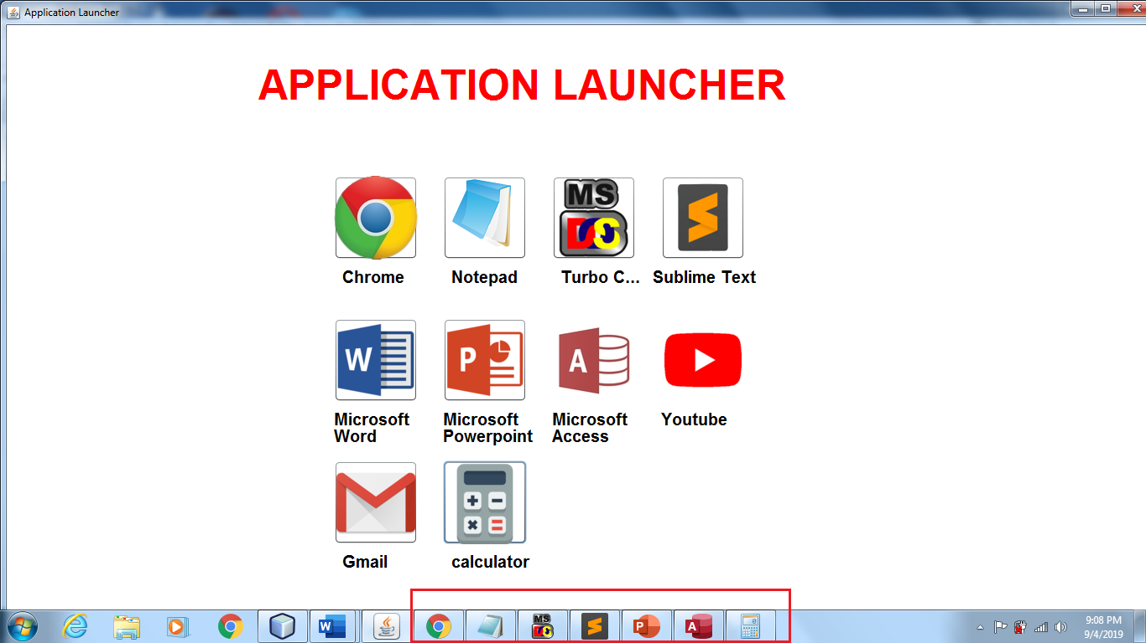

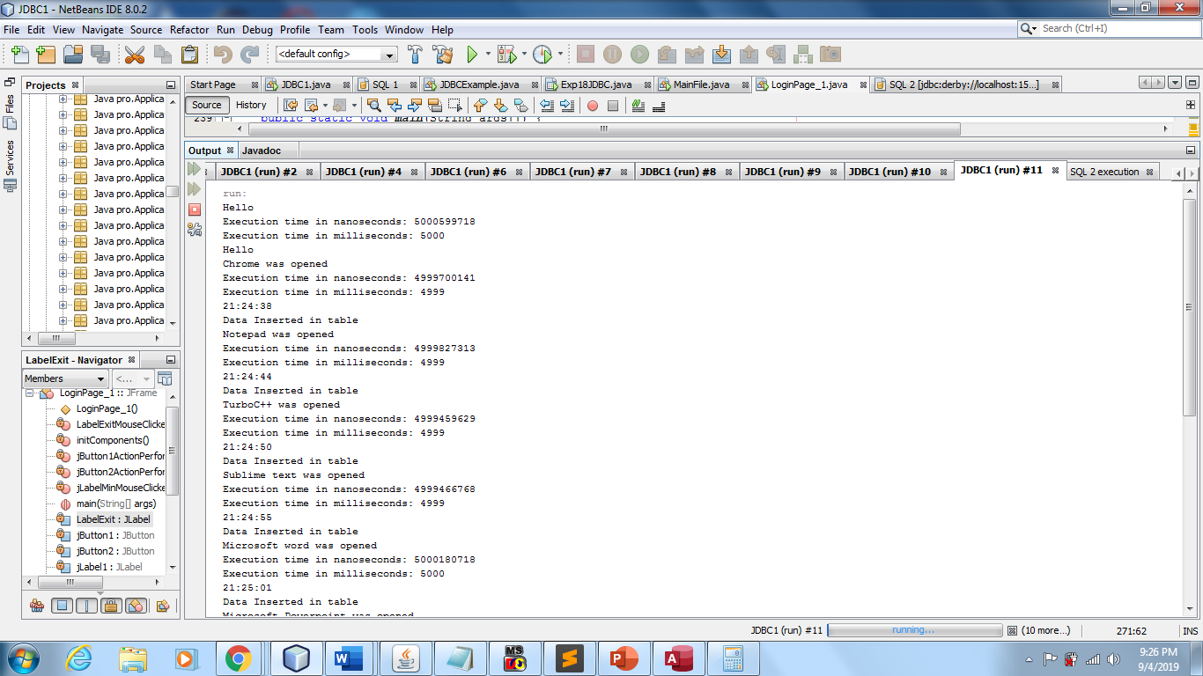

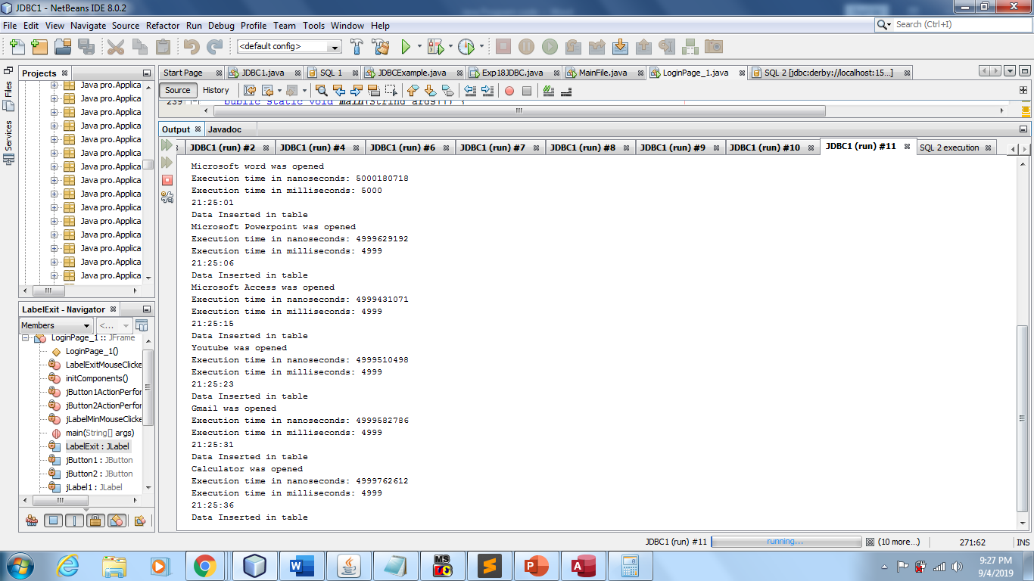

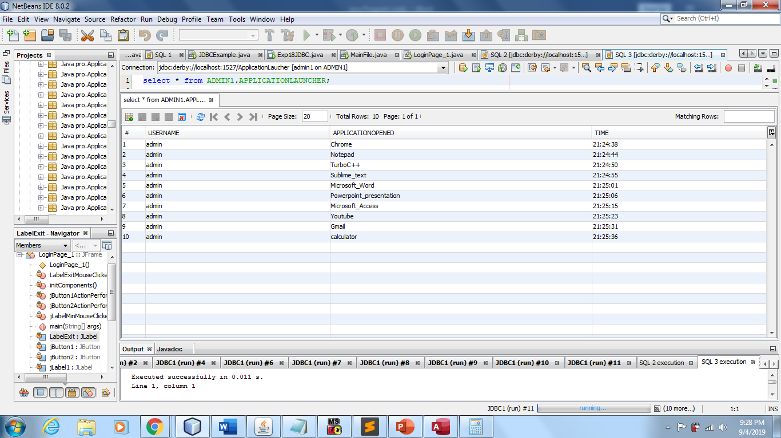

**Application Launcher Frame File path:** C:\Users\Shantanu\Documents\NetBeansProjects\JDBC1\src\Java_Project\MainFile.java

**Login Form file Path:** C:\Users\Shantanu\Documents\NetBeansProjects\JDBC1\src\LoginPage_1.java